UNIT-1
- Explain the concept of a set with suitable examples and discuss various types of sets such as universal set, subset, empty set, equal sets, cardinality of a set, power set, and Cartesian product.
- Using Venn diagrams, show the union, intersection, and set difference of two given sets.
- Explain the concept of Cartesian product and find A×B given A={1,2} and B={a,b,c}.
- Explain the various set operations with suitable examples, including union, intersection, disjoint sets, complement, set difference, and symmetric difference.
- Explain and justify the Principle of Inclusion and Exclusion with an appropriate example.
- Using a Venn diagram, show the relationship between the sets
A={2,3,5,7} and B={5,7,9,10}.
- Verify the logical equivalence of ~(p ∧ q) ≡ ~p ∨ ~q.
- (p∨q)→r≡(p→r)∧(q→r) state whether it is logically equivalent or not.

Is Q v (P ∧ ¬ Q) v (¬ P ∧ ¬ Q) a tautology? Explain by using truth table.
- What are the rules for constructing well-formed formulas in statement calculus?
- Demonstrate by Mathematical Induction that P(n)= 1+2+3+………+n=$\frac{n\left(n+1\right)}{2}$for any
n≥1.
- Using Mathematical Induction, show that 1+2+2²+………+2^{n} = 2^{n+1} -1 for any n≥1.
- Apply the method of Mathematical Induction to prove that 1²+2²+3²+…………+n² = $\frac{n}{6 }$
(n+1)(2n+1), n≥1.
- Show that every non-empty subset of positive integers contains a smallest element.
- Using Mathematical Induction, show that 1+2+2²+………+2^{n} = 2^{n+1} -1 for any n≥1.
- Proove by mathematical Induction that 1²+2²+3²+…………+n² = $\frac{n}{6 }$ (n+1)(2n+1), n≥1.
- Show that every non-empty set of natural numbers has a least element.
- List the steps involved in proving Euclid’s Algorithm.
- Find the GCD of :i) (12,33)
ii) (750,900)
iii)(252,105)
iv)(1005,105)
v)(48,18)
vi)(56,36)

UNIT-2
- Given the set A={1,2,3} and the relation
R={(1,1),(2,2),(3,3),(1,2),(2,1)} show that RRR is an equivalence relation on AAA.
- Verify the reflexive property of the relation a≤ba \le ba≤b on integers.
- State the definition of a reflexive relation along with one example.
- Explain the concept of a symmetric relation with a suitable example.
- Define a transitive relation and illustrate it with an example.
- What do you understand by an equivalence relation? Explain it with an example.
- Check if the relation
R={(1,2),(2,1)}R=\{(1,2),(2,1)\}R={(1,2),(2,1)} satisfies the condition of symmetry on A={1,2}A=\{1,2\}A={1,2}.
- Let A={1,2,3,4} and B={a,b,c}, R={(1,a)(1,b)(2,b)(2,c)(3,b)(4,a)}
  - S={(1,b)(2,c)(3,b)(4,b)}
  - Compute (a) R̄ (b)R∩S (C) R∪S (d)R⁻¹
- Let A={1,2,3,4} let R be the relation defined on A as a R b if and only if a<b.
- Identify the types A={1,2,3,4} B={a,b,c} f ={(1,a)(2,b)(3,c)(4,b)}
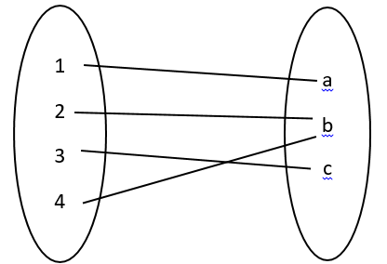
- A={1,2,3} B={a,b,c} F={(1,a) (2,b) (3,c)}, Identify the type.
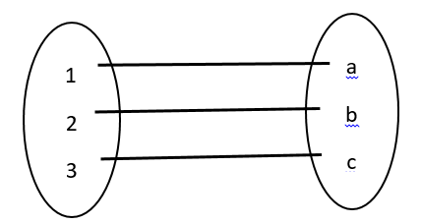
12.Let A={1,2,3,4}, B={a,b,c}f={(1,a),(2,b),(3,c),(4,b)}Identify the type of function.
13.Let A={1,2,3}, B={a,b,c,d}f={(1,a),(2,b),(3,c)}Identify the type of function.
14.Let A={p,q,r}, B={1,2}f={(p,1),(q,2),(r,1)}Identify the type of function.
15.Let A={x,y,z}, B={1,2,3}f={(x,1),(y,2),(z,2)}Identify the type of function.

UNIT 3 QB
- Explain the concepts of multigraph, weighted graph, and Euler graph using appropriate diagrams.
- Evaluate the indegree and outdegree of every vertex in the given directed graph.
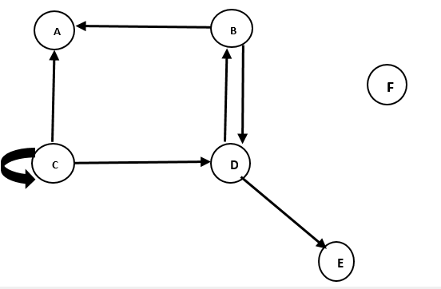

- Using the given graph, obtain the indegree and outdegree of its vertices.
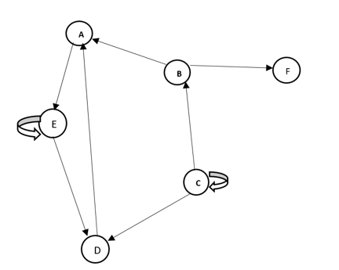
- Explain the concepts of Euler path and Euler circuit with the help of graphs.
- Check if the given graph contains an Euler path or an Euler circuit.
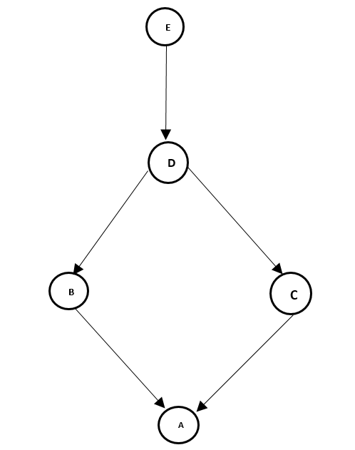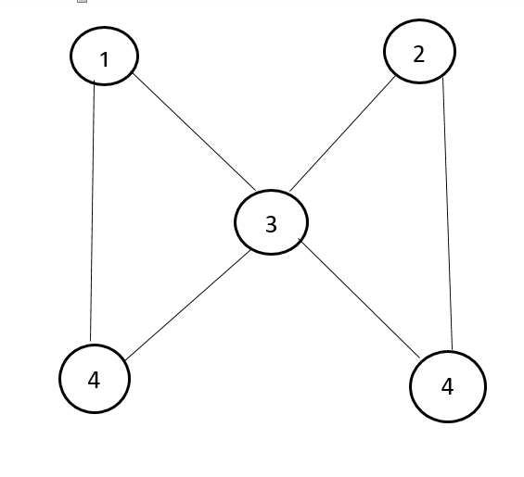
- Explain the concept of a circuit in a graph with the help of a diagram.
- State the meaning of a path in a graph and illustrate it graphically.
- Use Dijkstra’s algorithm to determine the shortest path.
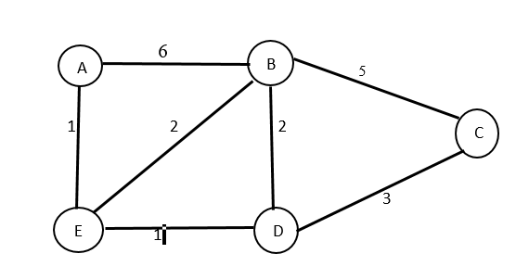
- Explain the concept of a circuit in a graph with the help of the above figure.
B
A

D
C

- Check whether the graph contains an Euler path. Give reason.
C
B
A

D
E

- Use Dijkstra’s algorithm to find the shortest path from vertex A to C.

4 5
B
C
A

2 3
D
E
1

- Explain Euler path and Euler circuit.Check whether the given graph contains an Euler path
or an Euler circuit.
A
C
B

D
E

UNIT 4 QB
- Demonstrate that the set G={1,-1,i,-i} is a group with respect to multiplication.
- State the definitions of a group, semigroup, and normal subgroup in algebra.
- A subgroup H of a group G is normal iff $x$ H $x$ ⁻¹ = H ∀ $x$ ∈ G
- Show that the matrices A =$\begin{matrix}1 & 0 \\ 0 & 1\end{matrix}$ $B=\begin{matrix}-1 & 0 \\ 0 & 1\end{matrix}$

C= $\begin{matrix}1 & 0 \\ 0 & -1\end{matrix}$ D = $\begin{matrix}-1 & 0 \\ 0 & -1\end{matrix}$

5.Show that the set of integers forms an group under addition.
6.Show that M₂ (R) is a group with respect to addition.
7.A subgroup H of a group G is normal iff g⁻¹ h g ∈ H, for every h ∈ H, g ∈ G.
8. Define Monoid , sub-group.

